 |  | Information sharing discussed with family (see page 3) | Yes ☐
We started this assessment on: |  | We completed this assessment on:

Who's in our family?
Please record details of who's in our family, who's living with us and who plays a part in our lives. If unborn, state name as unborn baby and mother’s name, e.g. unborn baby of Ann Smith and record expected date of delivery.
Name | Surname | Gender  M/F/U | DOB | Relationship | Parental responsibility  Y/N | Living at the family address provided below  Y/N | Language | Ethnicity | Religion | Disability

Family contact details

House Name/No
Street
City
Postcode
Telephone No.
Mobile No
Email

Who is undertaking this assessment with our family?
Name & surname | Organisation | Phone | Email
Who else is working with our family? Please consider all universal services and any additional services working with adults or children
Organisation | Services | Name & Contact details

Useful information to know when working with our family?

Your family's consent and privacy
Your family's information will be used to carry out your Early Help Assessment, to provide you and your family with Early Help Services and to monitor your progress along your journey. To complete this process we may gather and share information with services who are working with you, please state below the organisations that you are happy for us to gather and share information with. This may be shared during the assessment process, during on-going work, at team around the family meetings and to monitor progress.
Portsmouth City Council | ☐ | Children's school, nursery or college | ☐
NHS Trust Health services/GP | ☐ | Housing services and providers | ☐
Children, Family and education services | ☐ | Hampshire Constabulary | ☐
Portsmouth's Multi-Agency Safeguarding Hub | ☐ | Probation services | ☐
Domestic abuse services | ☐ | Government departments | ☐
Adult mental health services | ☐ | Other | ☐
Adult substance misuse services | ☐ | Consent to all | ☐

In addition to this, the Council engages in local and national projects that support the research and evaluation of services and helps shape the future of support for families. To do this, the Council's 'Stronger Futures Programme' may share your information with other government departments and local agencies to enable us to monitor progress and evidence successful work that you and your family complete in moving towards better outcomes. This is an important source of funding for support services and helps us to invest in the Early Help network in Portsmouth. Partner agencies that do not currently hold information about your family, such as Hampshire Constabulary, may need to create an Early Help record and reference for you so they can track your family's progress. Any records created solely for these purposes will be deleted on completion of the Early Help programme. A list of some of the example agencies which this may include is as follows:

NHS Trusts/Departments/GP, Children & Family Services, Schools and Education Services, Housing Services & Providers, Domestic Abuse Services, Hampshire Constabulary, Probation Services, Adult mental health services, Adult substance misuse services, Department for Work & Pensions & Central Government.

Privacy notice
The Council respects your family's privacy and will only use your information where it is lawful. Your information will be kept securely and for no longer than is necessary.
The Council and partner organisations have a duty to share information with one another where they have concerns that an infant, child or young person has been harmed or abused, or is at risk of harm or abuse. In these circumstances we do not need consent to share information.
We may be required by law to disclose your personal information without your consent for the purposes of preventing or detecting crime/fraud or apprehending and prosecuting offenders (for example to the police, Department for Work and Pensions or as part of the National Fraud Initiative) or where we have a statutory duty to do so.
To find out more about how your families' information may be used for Early Help, contact: EarlySupportReferralPanel@secure.portsmouthcc.gov.uk
To find out more about how the Council uses personal information, see the Data Protection Privacy Notice on the Council's website or contact dataprotection@portsmouthcc.gov.uk (telephone 023 9268 8482)
To request a copy of your records or to ask the Council to stop using your information, contact: dataprotection@portsmouthcc.gov.uk

Consent
☐ I Consent to the Early Help Assessment (PLEASE TICK)
I consent to the Portsmouth Early Help Assessment being undertaken and confirm I have parental responsibility for the child or children in this assessment. I understand that I may withdraw from this process at any time. I /we agree to information being shared about me/us and my/our family with the Council's partner organisations in order to provide me/us and my/our family with Early Help Services and Support.
☐ I Consent to sharing our family's information for Stronger Futures programme (PLEASE TICK)
I understand that selected information about my family and the Early Help Services they receive will also be used by the Council, partner organisations in Portsmouth and Central Government to plan and evaluate Early Help Services for families.

PLEASE ENSURE THAT THIS FORM IS PHYSICALLY SIGNED BEFORE SENDING THE ASSESSMENT TO PCC - INCLUDING CHILDREN OVER 12YRS

Name of parent/carer | Signature | Date
Name of family member | Signature | Date
Name of professional | Signature | Date

Is there anyone else who has parental responsibility for this child/ren and needs to be informed of this assessment process?
Yes ☐ No ☐

If yes, please give details:
Name:
Address:
Phone/Email:

Organisational complaints procedure provided Yes ☐ No ☐

If you wish to withdraw consent to the 'Early Help' assessment or the 'Stronger futures' programme you can do so at any time. To notify us that you wish to withdrawn consent please contact EarlySupportReferralPanel@secure.portsmouthcc.gov.uk

Family Genogram

Please draw the family genogram below including all children, parents and any unborn children:
Unborn
Female
Male

When answering the questions below, please take account of all family members in the household. The aim is to get an overview of the needs of our whole family across all six headline outcome areas.

1.Families are reducing offending and anti-social behaviour |  |  |  | Who? (e.g. mum, Billy)
In the last 12 months:
Have any of the children been in trouble with the police? |  | Yes ☐ | No ☐
Have any of the adults or children been involved or sanctioned for anti-social behaviour? |  | Yes ☐ | No ☐
Is there a young person at risk of offending behaviour including gang activity, drugs running and radicalisation? |  | Yes ☐ | No ☐
Is there an adult serving a prison sentence? |  | Yes ☐ | No ☐
Are any of the adults serving a community order or suspended sentence? |  | Yes ☐ | No ☐
Are there any other issues relating to crime and/or anti-social behaviour that are concerning you or the family? |  | Yes ☐ | No ☐
Based on these factors, what would you score Crime and ASB overall?
Issue not present/outcome ☐ achieved | Making progress ☐ | Needs improvement ☐ |  | Area of concern ☐

2. Children are attending school and parents are supporting their learning |  |  |  |  | Who? (e.g. mum, Billy)
Over the last 3 consecutive terms, have any of the children:
Been persistently absent from school? Below 90% attendance |  |  | Yes ☐ | No ☐
Been chronically absent from school? Below 50% attendance |  |  | Yes ☐ | No ☐
Been permanently excluded? |  |  | Yes ☐ | No ☐
Received a fixed term exclusion of 3 days or more? |  |  | Yes ☐ | No ☐
Child with social, emotional and behavioural difficulties registered in an alternative education provision? |  |  | Yes ☐ | No ☐
Child is not registered with an early years setting? |  |  | Yes ☐ | No ☐
Are the family eligible for 2 Year funding? |  |  | Yes ☐ | No ☐
Have they taken it up? |  |  | Yes ☐ | No ☐
Are there any other education-related issues that concern you or the family |  |  | Yes ☐ | No ☐
Based on these factors, what would you score education overall?
Issue not present/outcome ☐ achieved | Making progress ☐ | Needs improvement ☐ |  |  |  | Area of concern ☐

3.Children are safe from harm and well-parented |  |  |  |  | Who? (e.g. mum, Billy)
The family are Identified as needing an 'Early Help' assessment? |  |  | Yes ☐ | No ☐
The family have had safeguarding concerns, recently (within 6 months) stepped down from a Child in Need or Child Protection plan? |  |  | Yes ☐ | No ☐
Is there a need to improve parenting capacity? |  |  | Yes ☐ | No ☐
Is there a child with SEN within the family? |  |  | Yes ☐ | No ☐
Are the family managing the SEN and coping well? |  |  | Yes ☐ | No ☐
Is there a child identified at low, medium or high risk of Child Sexual Exploitation (CSE)? |  |  | Yes ☐ | No ☐
Based on these factors, what would you score parenting overall?
Issue not present/outcome ☐ achieved | Making progress ☐ | Needs improvement ☐ |  |  |  | Area of concern ☐

4. Adults are working, young people are in education, employment or training and families are managing finances |  |  |  |  | Who? (e.g. mum, Billy)
Are any of the parents/carers in the household in receipt of out of work benefits or Universal credit - work related conditions? |  |  | Yes ☐ | No ☐
Is there a young person (post-16) who is not in education, employment or training (NEET)? |  |  | Yes ☐ | No ☐
Is there a young person of school age who is identified as 'at risk' of NEET? |  |  | Yes ☐ | No ☐
Does the family have significant rent arrears? |  |  | Yes ☐ | No ☐
Are the family at risk of eviction? |  |  | Yes ☐ | No ☐
Are family finances/debts impacting on ability to provide basic care for adults and children? |  |  | Yes ☐ | No ☐
Does the family have appropriate support to manage debt? |  |  | Yes ☐ | No ☐
Are there any other Housing, employment, training or money issues that concern you or the family? |  |  | Yes ☐ | No ☐
Based on these factors, what would you score employment and finances overall?
Issue not present/outcome ☐ achieved | Making progress ☐ | Needs improvement ☐ |  |  |  | Area of concern ☐

5. Families are supported around domestic abuse |  |  |  |  | Who? (e.g. mum, Billy)
Are any family members experiencing domestic abuse (including honour based violence)? |  |  | Yes ☐ | No ☐
Has there been domestic abuse in the recent past that is still impacting on the family? |  |  | Yes ☐ | No ☐
Has the household been subject to at least one police call out for domestic abuse in the last 12 months? |  |  | Yes ☐ | No ☐
Are any of the family members accessing support from domestic abuse services (within the past 12 months)? |  |  | Yes ☐ | No ☐
Are any of the young people (16+) or adults in the household known to be perpetrators of domestic abuse? |  |  | Yes ☐ | No ☐
Have any family members been deemed at 'High Risk' of harm and been known to MARAC in the previous 2 months? |  |  | Yes ☐ | No ☐
Based on these factors, what would you score domestic abuse overall?
Issue not present/outcome ☐ achieved | Making progress ☐ | Needs improvement ☐ |  |  |  | Area of concern ☐

6. Children and families are healthy |  |  |  |  | Who? (e.g. mum, Billy)
Is there a new mother or expectant mother at risk of poor health outcomes (including mental and physical health)? |  |  | Yes ☐ | No ☐
Is there a child with developmental delay identified at the 2-2.5 year old ages and stages check? |  |  | Yes ☐ | No ☐
Is there an adult with mental health problems? |  |  | Yes ☐ | No ☐
Is there a child with mental health problems? |  |  | Yes ☐ | No ☐
Is there an adult with identified substance misuse? |  |  | Yes ☐ | No ☐
Is there a child using alcohol or substances? |  |  | Yes ☐ | No ☐
Are there family members with a long term health condition which impacts on family functioning? |  |  | Yes ☐ | No ☐
Are the family struggling to manage health needs, including missed appointments? |  |  | Yes ☐ | No ☐
Are the children registered with a GP and dentist and attending regular check-ups? |  |  | Yes ☐ | No ☐
Based on these factors, what would you score health overall?
Issue not present/outcome ☐ achieved | Making progress ☐ | Needs improvement ☐ |  |  |  | Area of concern ☐

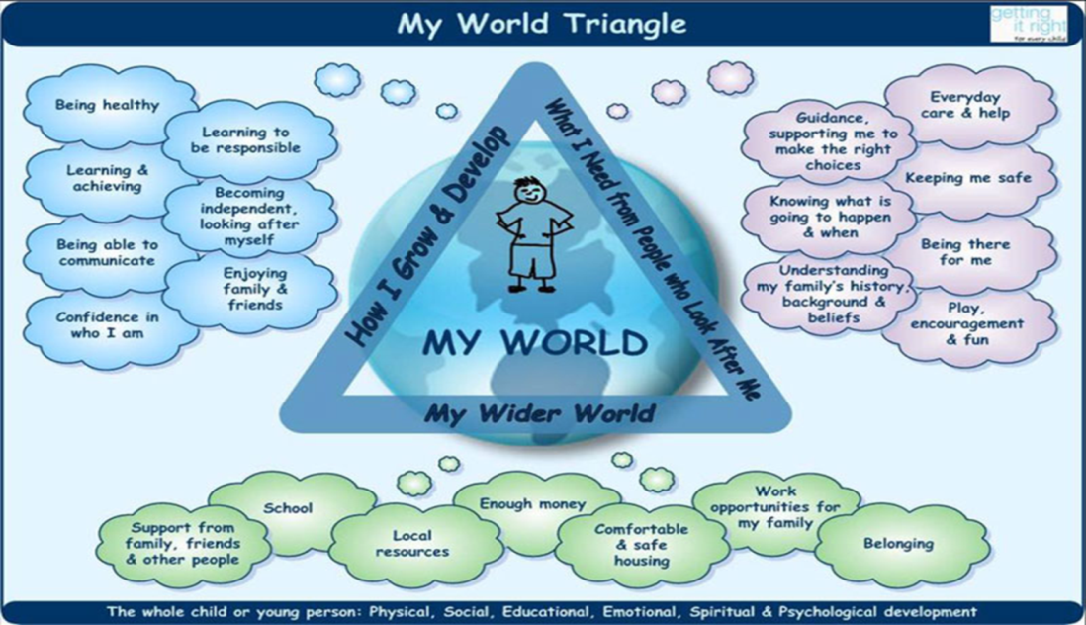

What's going on in our family?
Our family story - what has happened in the past and what is happening now? Key events in our family's life - how have they affected where we are now? What is our family good at? What have we tried in the past, what worked, what didn’t help and who helped us? Is there anything that means there is a risk of harm to ourselves or others?

Our family story:
Anti-Social behaviour (How I grow and develop)
Education (How I grow and develop & My wider world)
Parenting (What I need from people who look after me)
Work opportunities & Finances (My wider world)
Domestic Abuse (What I need from people who look after me)
Health and wellbeing (How I grow and develop)

Children's comments
I feel happy when…

I am proud of…because

I feel worried about….

Me and my family need to make the following changes to make things right:

Parents/Carers' comments
I feel happy when….

I am proud of…because…

I feel worried about……

I need to make the following changes to make things right:
I need to be more proactive and sort things out.

On the scale below, my level of confidence about making these changes is:

1 | 2 | 3 | 4 | 5 | 6 | 7 | 8 | 9 | 10

What will be the hardest thing for me in making changes?

Summary/ Analysis/ Identified Risks
What are the main things our family want to change, improve and strengthen? How will we do this and overcome any barriers?

Family Plan
Please ensure that any areas identified as 'needs to improve' or an 'area of concern' are included in the plan
What are we going to change/ improve/ strengthen?  (Link to needs identified in 'What's going on in our family?) | What are we going to do to make this happen?  (Activities) | Who in our family needs to do this and what support will we need? | By when?  (Specific timescales) | Outcome for our family  (How will we know when things have improved / what will life be like for the family)?

When should we get back together again to review the plan and the progress?
Date & time:

Venue:

Lead Professional:

Date completed:
Parents'/Carers' signature: |  | Date:
Young person's signature: |  | Date:
Worker's signature: |  | Date:
Manager's signature: |  | Date:

Once completed, this assessment must be sent to Portsmouth Early Help:

Send to: Somerstown Family Hub, Omega Street, Portsmouth, PO5 4LP
Email: EarlySupportReferralPanel@secure.portsmouthcc.gov.uk
Telephone: 023 9282 1816

OFFICE USE ONLY
Consent form signed? | Yes ☐ No ☐ | Address added to ADMS? | Yes ☐ No ☐
Worked with before in TF P1? | Yes ☐ No ☐ | All paperwork scanned and linked to involvement? | Yes ☐ No ☐
Worked with before in TF P2? | Yes ☐ No ☐

