Welcome Back to School

Information for professionals working with families
August 2020

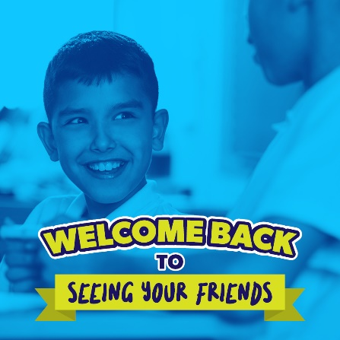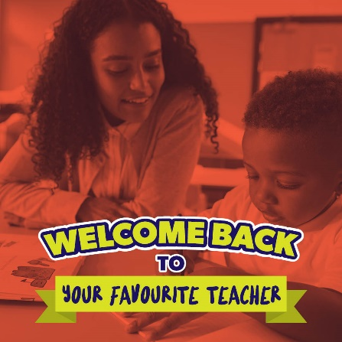
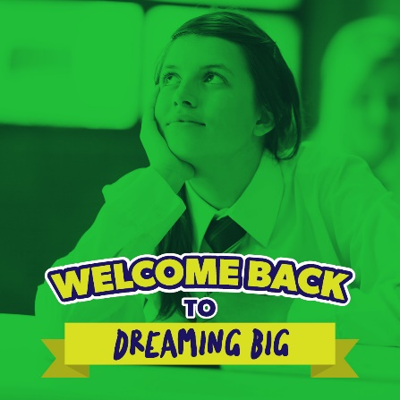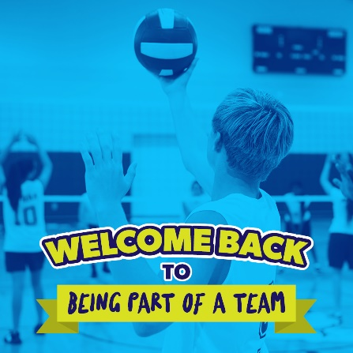

Background information
As early years settings, schools and colleges prepare for a return of all year groups in September, we want to extend our support to you as you talk to families about how they will be welcomed back to school.
We know that some families are anxious about the return to school in September. Those families with children transitioning from early years to reception, or primary to secondary school, those whose children have special educational needs, disabilities or underlying health conditions, as well as BAME families may have additional, specific concerns.
We are working with schools and partner organisations to promote a city-wide 'welcome back' message to families in Portsmouth. This will support each school's individual back-to-school plans.
The aim of our welcome back activity is to:
- Reassure families that schools and teachers are ready and eager to welcome pupils back into school
- Support understanding of the many benefits of being in school
- Explain some of the steps being taken to ensure pupils are as safe as possible
We hope you will find this pack helpful to support your conversations with families over the summer and at the start of term.

FAQs
We've put together FAQs using some of the concerns raised by families about the return to school. Please use these messages (where you feel appropriate) when you have conversations with parents and carers about returning to school:

Will my child struggle with school at the start of term? I'm worried they are behind and/or too anxious to return.

- When schools return in September their priorities will be helping pupils settle back into the school community and looking after their health and emotional wellbeing. Teachers and staff will be dedicated to supporting the transition back to school and looking after every pupil's wellbeing above all else.

- Schools have seen that pupils who came back before the summer holidays returned eagerly and settled very quickly. Children and young people are resilient and able to cope with change with the right support.

- Speak to your school about any specific concerns you have. Your school will listen to your concerns and work with you make sure you have the information and support you need to feel comfortable about going back to school.

Will school be different in September because of coronavirus safety measures?

- School have been working hard to prepare their buildings and classrooms for the new school year. Their priority is to keep pupils as safe as possible while making sure that the school day and classrooms feels familiar and normal.

- Schools will be following national and local guidance on the pandemic as it is reviewed and updated over the coming months. Your school will be able to provide more information about the plans they have in place for September. It is best to check the school's website and social media pages for specific information.

What happens if there is an outbreak once term has begun?

- In the event of an outbreak within the local community, schools will follow local guidelines and the outbreak plan created by Portsmouth City Council. www.portsmouth.gov.uk is a good source of up-to-date information on local plans and procedures in the event of an outbreak.

What support will be available to my child at school?

- Schools will have support available for any pupils who may have lost a loved one during the pandemic or experienced difficulties over the past few months.

- Schools will be talking to pupils when they return about how everyone can work together to create a safe and enjoyable environment within the school.

- If you are worried that your child won't be able to cope returning to school, please contact the school. They will be able to talk about the steps they are taking to resettle all pupils and how they can help your child individually.

- Vulnerable children, or those with underlying health conditions, shouldn't feel excluded from returning to school in September. Your school will work with you to create an individual 'Welcome Back Plan' for your child that meets their specific needs and addresses any worries or concerns you may have.

What happens with children who were previously shielding?
- The government's general expectation is that the vast majority of children who were previously shielding will be able to return to school while the infection rate remains low, but may be asked to self-isolate again if the infection rate rises. Schools are asked to liaise with the school nursing service if they have any concerns about the implications of children's health needs on their return to school.

Schools may decide to put in place individual 'Welcome Back to School' plans for children who need additional support to return to school. Any other professional involved with the child such as the social worker or specialist health professionals will be asked to contribute to the Welcome Back to School plan. Schools are expected to immediately provide access to remote education for any child who is unable to return to school to comply with medical advice.
To support our positive back to school messages, we are keen to avoid using certain language when talking to families:
- Avoid reinforcing messages about 'falling behind' academically or the need to 'catch up' - focus on how well they've coped during lockdown.
- Avoid talking about 'missing out' either socially or academically - speak about the benefits of being in school.
- Avoid talking about penalties for poor attendance at the start of term - focus on the reasons to go back.
- Avoid talking about the 'risks' and 'dangers' of attending school - look at the work schools are doing to make it as safe as possible.
Tips for preparing for back to school
We have prepared some practical tips and advice to help families get ready for back to school:
- Talk to your child about what they are looking forward to about going back to school. For example, seeing their friends, the playground, or their favourite subjects.

- Chat about what school may be like when they go back. Some schools will share videos or pictures of the classrooms online that you could look at together.

- Listen to your children's concerns and let them know its ok to feel anxious about going back to school. Address any misinformation they have and encourage them to ask questions.

- Let them know that teachers and staff will be there to support them and answer their questions. Teachers will be focussing on helping them feel settled, safe and happy above all else.

- Think about your school routine. Try on the uniform, check arrangements for breakfast and after school clubs and get into the habit of getting up early and going to bed at the right time.

- Plan ahead for how you will get to school. Think about a fun way to actively travel to school. Try out the route before terms starts and consider if there are any social distancing measures in place on the way.

- Encourage your child to see friends before term starts to help them feel part of the school community again. Arrange a small outdoor get together or online catch up.

- Talk to your children when you feel calm as they'll pick up on adults' anxieties. It's ok not to have all the answers yourself but remember local support and information is available if you want it.

The importance of school
We have prepared these messages about why school is so important for young people. You can use them to shape conversations you may be having with families who are considering keeping their children at home in September:
- Children seek independence. They need to feel settled and develop a sense of belonging, outside their homes and families.

- Children and young people are sociable. They benefit enormously from doing things together as a school group and sharing experiences with their peers.

- Children are naturally inquisitive. They seek out adventure and thrive on being active, and interacting with other young people. Schools are set up for this and will help your child build friendships and have fun while learning.

- Children need structure, routine and consistency. Being at school will give your child the structure they need to thrive and adapt to any new and changing routines at home.

- Evidence shows that being in schools helps children be more successful in all areas of life, including their home life and into their work life. As well as valuable face-to-face teaching time, pupils have access to extra-curricular opportunities, careers support and peer-to-peer learning.

- Being in school is the best way for children and young people to keep on top of their learning, to receive support and guidance from teaching staff and have access to the tools and resources they need to progress.

- The interactive learning opportunities are far greater for children in the classroom. Our teachers are working hard to develop an engaging curriculum and lesson plans for the new school year, so pupils will be able to take advantage of a wide variety of learning tactics and resources.

Additional resources
Here are some helpful sources of information about preparing for back to school for you to draw on or to sign-post to families:
Portsmouth City Council has up-to-date information and advice about returning to school in September on its coronavirus information pages for schools and families.

The Association for Child and Adolescent Mental Health has prepared a video and information to help parents and teachers deal with apprehension and anxiety when returning to school.

Portsmouth Education Partnership - an overview of the coronavirus support available to children, families and schools.

Portsmouth MHST is offering parent carers workshops over the summer holidays to support returning to school.

Ethnic Minority Achievement Service (EMAS) has a team of Bilingual Learning Assistants who can be used to help reach families whose first language isn’t English with back to school information.

Portsmouth Parent Voice - support for parent carers of young people with additional
needs and disabilities.

Portsmouth Local Offer - lists the information, support and services available in our local area for children and young people aged 0-25 with special educational needs and or a disability.

Portsmouth City Council has advice for families whose children are moving on from nursery to reception or primary to secondary school.

Gov.uk has national coronavirus guidance and the latest rules and advice, including information about self-isolation following international travel.

