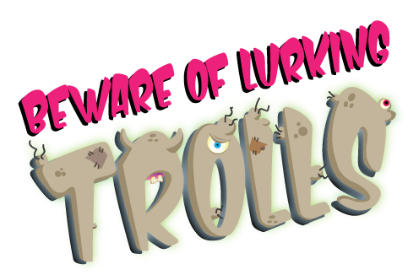

Toolkit for schools
June 2021

Background information

The internet should be a fun, safe space for children to explore, engage with friends and learn more about the world around them. However, we know all too well that this is often not the case and there are many form of harm they may encounter online.

In response to the challenges parents, carers and schools face in safeguarding children, and in recognition of the growing and changing dangers children face online, the Local Safeguarding Children Partnerships (LSCPs) in Hampshire, Isle of Wight, Portsmouth and Southampton have re-launched the successful Lurking Trolls campaign.

The Lurking Trolls campaign is designed for 7 to 11 year olds with the aim of building their digital resilience. We don't want to stop children being online so we hope that this campaign will help children to better understand when they may be at risk, know what to do if something goes wrong, and be able to recover from any difficulties or upsets.

Meet the trolls
A cast of grisly trolls has been created to bring to life the dangers children may come across online. In their appearance, character and actions they depict issues such as bullying, exploitation, radicalisation, body image and fake news.

Children can read about the trolls and learn how to recognise and defeat them by reading the trolls books, listening to the narrated versions online, exploring the trolls fact files and listening to trolls music. We hope you will be able to use the trolls and supporting teaching resources to drive conversations and learning about online safety.

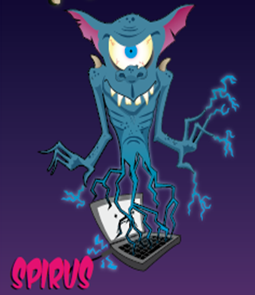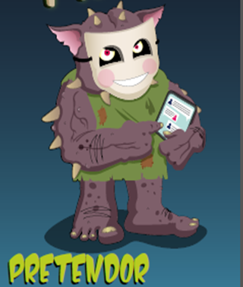
Bullying Privacy settings Spyware & viruses Grooming & exploitation

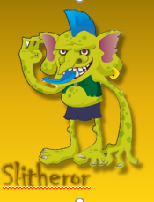
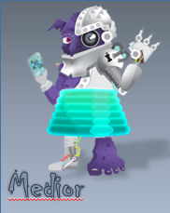
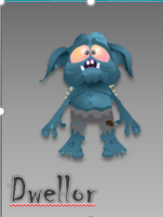
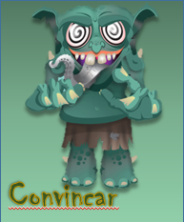

Location sharing Radicalisation Fake news Anxiety & mental health

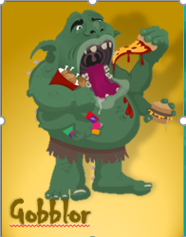
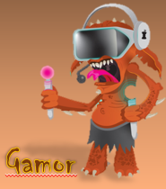
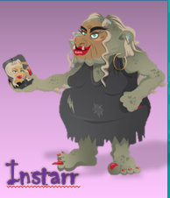

Online gaming & Photo filters & Healthy eating cyberbullying negative self-image

Example letter for parents and carers

Please feel free to use and adapt this letter template to suit your school and pupils and to encourage engagement with the Lurking Trolls campaign.

Dear parents and carers

Meet the Lurking Trolls! An army of gruesome characters that we're using to help children in key stage 2 learn how to spend time online safely.

The internet should be a fun, safe space to explore, engage with friends and learn more about the world. However, we know that children may come across harmful, confusing or even dangerous things online. We want children to know what to do if something goes wrong and how to recover from any difficulties or upsets.

The Local Safeguarding Children Partnership has developed the trolls campaign - with a book, website and videos - to help children aged 7 to 11 learn about online safety and to help schools, parents and carers have meaningful conversations about difficult topics.

Please do read and chat to your child about the trolls book, Peril of the Possessed Pets. They can explore more at www.lurkingtrolls.com - listen to a narrated version of the book, look at fun fact files about the trolls and watch trolls cartoons. There is also lots of information and advice for parents and carers as well at www.lurkingtrolls.com. You can find out more about how to talk to your child about online safety, how to help them stay safe online, and what to do if something goes wrong. We hope you find the trolls helpful and entertaining!

Example newsletter or website story

Meet the Lurking Trolls! An army of gruesome characters that we're using to help children in key stage 2 learn how to spend time online safely. We want children to know what to do if they come across something harmful, confusing or even dangerous when they're online and how to recover from any difficulties or upsets.

The Lurking Trolls campaign includes a book, website and videos. It can help schools, parents and carers have meaningful conversations about online safety. Visit www.lurkingtrolls.com and listen to narrated stories about the lurking trolls and watch trolls cartoons. There is also lots of information and advice for parents and carers about helping your child stay safe online and what to do if something goes wrong.

Example social media post

Meet the Lurking Trolls! An army of gruesome characters that we're using to help children in key stage 2 learn how to spend time online safely and what to do if they come across something harmful or confusing online.

Visit www.lurkingtrolls.com with your child and listen to stories about the lurking trolls, watch trolls cartoons and get tips for staying safe. There is also lots of useful information and advice for parents and carers.

